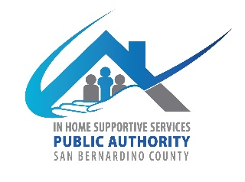
San Bernardino County
IHSS Advisory Committee
784 E Hospitality Lane
San Bernardino CA 92415
March 6, 2024, WEDNESDAY
9:00 AM to 12:00 PM
IHSS Conference Room B

- Call to Order

- Approve Minutes from February 7, 2024

- IHSS Advisory Committee Introductions and Member Reports

- Service Employee International Union (SEIU) Local 2015 Presentation—California Long Term Caregivers

- Public Comment on Non-Agenda Items
Please note: Public Comment on agenda items will be heard during that item. Public comment is limited to 5 minutes per speaker. Submit Public Comment card to Chair.

IHSS Public Authority Report -- Myette Christian/Melissa Cardenas

Department of Aging and Adult Services Report-- Sheila Johnson

- Old Business
  - Amendment of By-laws (submit to council to be approved by Board of Supervisors)
  - 36th Annual Adult Protective Multi-Disciplinary Team (MDT) Conference May 22, 2024

- New Business
  - Fiscal Report-Fiscal year (July 1, 2023-June 30, 2024)
  - Recruitment
    - Review new applications.

- Discussion/Resources
  - CICA Report
  - Caring Futures (The Arc of CA)—Giving free online classes beginning March “Designing a Support Plan for Your Family Member” and another session on “Well-being for the Caregiver”
https://www.caringfutures.org/classes
  - Justice in Aging—25 Common Nursing Home Problems and How to Resolve Them
https://justiceinaging.org/25-common-nursing-home-problems/?eType=EmailBlastContent&eId=0dedd6c4-f687-4668-929e-21f3cec393a7
  - All County Letter (ACL) No. 24-02 (01/02/24): IHSS Career Pathways Program Extension-- https://www.cdss.ca.gov/Portals/9/Additional-Resources/Letters-and-Notices/ACLs/2024/24-02.pdf?ver=2024-01-19-102928-457
    - https://www.cdss.ca.gov/inforesources/cdss-programs/ihss/ihss-career-pathways-program
    - https://www.capaihss.org/resources/career-pathways/
    - https://homebridgeca.arlo.co/w/courses/

- Adjournment

