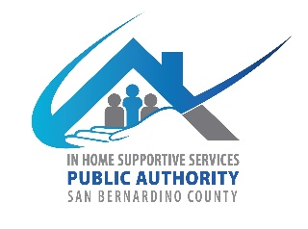
San Bernardino County
IHSS Advisory Committee
July 13, 2022 WEDNESDAY
9:00 AM to 12:00 PM
Teleconference

- Call to Order

- Approve Minutes from May 4, 2022

- IHSS Advisory Committee Introductions and Member Reports

- Public Comment on Non-Agenda Items
Please note: Public Comment on agenda items will be heard during that item. Public comment is limited to 5 minutes per speaker. Submit Public Comment card to Chair.

IHSS Public Authority Report -- Rosa Hidalgo/Myette Christian

Department of Aging and Adult Services Report-- Chris Tarr/Sheila Johnson

- Old Business
  - Status on IHSSAC application translation into Spanish
  - IHSS Advisory Committee Officer nomination/election (Article; Bylaws 4.2)
  - Certificates of Appointments
  - Introductions to the Board of Supervisors
- Present alternatives in how committee can introduce themselves to the Board

- New Business
  - Fiscal Report-Fiscal year (July 1, 2022-June 30, 2023)
  - Recruitment

- Discussion/Resources
  - CICA Report
  - All County Letter
    - No. 22-43—Subject: In-Home Supportive Services Quality Improvement Action Plan Templates
https://www.cdss.ca.gov/Portals/9/Additional-Resources/Letters-and-Notices/ACLs/2022/22-43.pdf?ver=2022-06-22-130638-253 (Issue Date June 21, 2022)
  - All County Information Notices
- No. 1-48-22—Subject: Modifications to Case Management, Information and Payrolling System for In-Home Supportive Services
https://www.cdss.ca.gov/Portals/9/Additional-Resources/Letters-and-Notices/ACINs/2022/I-48_22.pdf?ver=2022-06-30-105739-163 (Issue Date June 10, 2022)

- Adjournment

