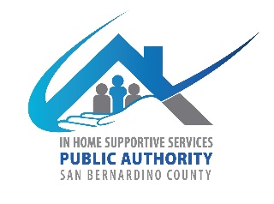
San Bernardino County
IHSS Advisory Committee
784 E Hospitality Lane
San Bernardino CA 92415
September 6, 2023, WEDNESDAY
9:00 AM to 12:00 PM
IHSS Conference Room A

- Call to Order

- Approve Minutes from July 26, 2023

- IHSS Advisory Committee Introductions and Member Reports

- Public Comment on Non-Agenda Items
Please note: Public Comment on agenda items will be heard during that item. Public comment is limited to 5 minutes per speaker. Submit Public Comment card to Chair.

IHSS Public Authority Report -- Myette Christian/Melissa Cardenas

Department of Aging and Adult Services Report-- Sheila Johnson

- Old Business
  - Amendment of By-laws (submit to council to be approved by Board of Supervisors)
    - Review language
  - Take Committee Group Photo

- New Business
  - Fiscal Report-Fiscal year (July 1, 2023-June 30, 2024)
  - Recruitment
    - Review new applications.

- Discussion/Resources
  - CICA Report
  - Meeting Frequency
  - Remote Meeting Requests
    - Review added “just cause” process to bylaws.

- Adjournment

