EMACS now offers the ability to acknowledge new or revised Policy’s or Standard Practices.
You now have a tile that is labeled “Policy/Standard Practice”
- If there is a number in the lower right-hand corner of this tile, that means that there is a document that requires your attention.
- Once you have completed the acknowledgement of the Policy or Standard Practice, the number will be removed.
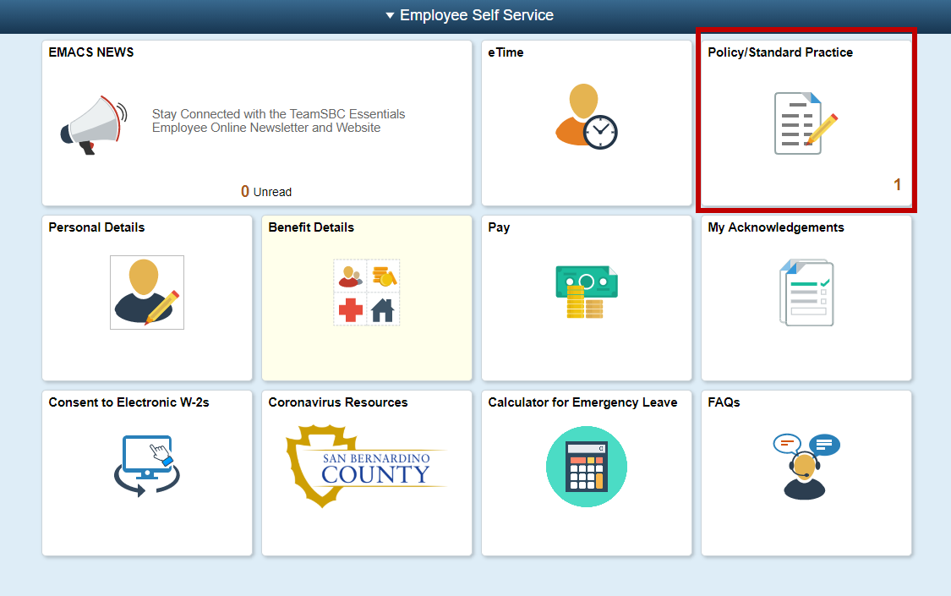
Once you select the “Policy/Standard Practice” tile, this screen will appear:
- This shows your employee ID and the status of this Policy. In this case, no steps have been completed
- You will also see an arrow under the continue heading, select this to proceed.
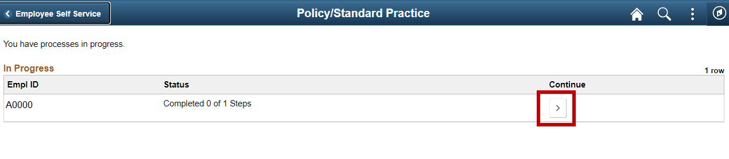

The Policy or Standard Practice opens for your review
- Read through the Policy or Standard Practice
- Read through the acknowledgement section
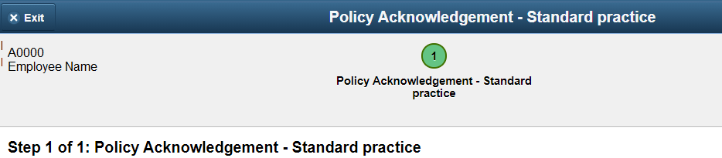
Once you have read through the Policy or Standard Practice, you will need to acknowledge receipt.
- Select the checkbox next to “I acknowledge receipt of this Policy or Standard Practice”
- Select Save
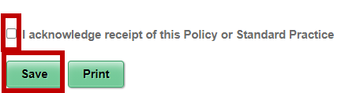
Once you select SAVE, you will be asked to verify your identity.
- Enter your EMACS password
- Select CONTINUE
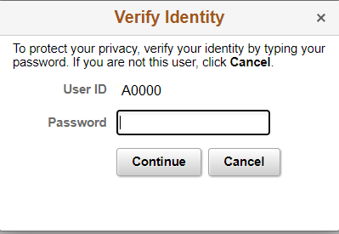
Once you have verified your identity, you will see your information on the bottom of the form. This shows your name, your employee ID and the date and time that you acknowledged the Policy or Standard Practice.
From here, you can select PRINT and a new window will appear that will allow you to print this Policy or Standard Practice for your records. EMACS also store this for future review, so you can always see it again without having to rely on a printed copy.
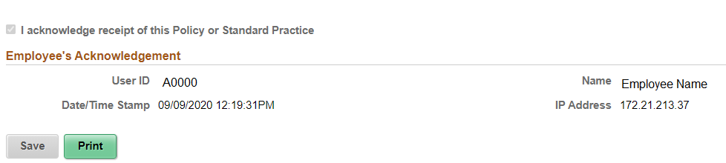
When you are done, select EXIT on the top left corner of the EMACS screen
To review a Policy or Standard Practice that has already been acknowledged, start from the home screen. The “My Acknowledgements” tile will show a number in the lower right-hand corner if there is a document available to view.
Select this tile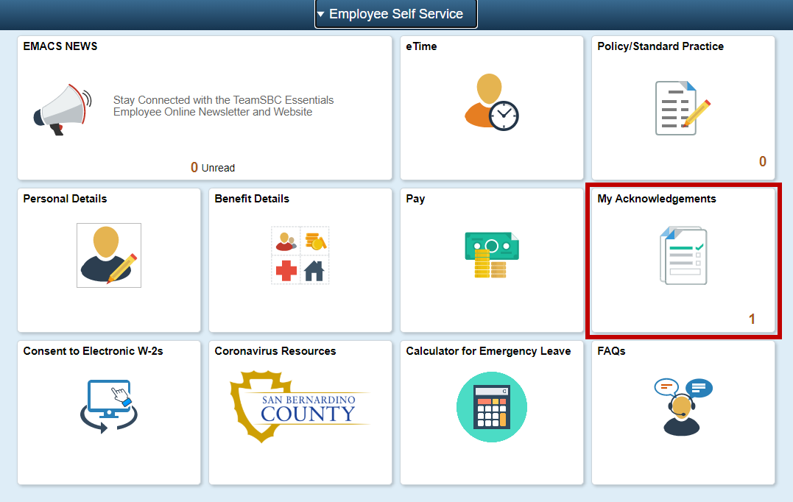
This page lists any Policy or Standard Practice that you have acknowledged.
Select the line item you want to view
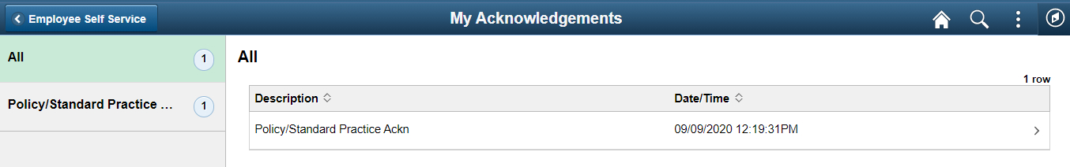
Your acknowledgement will open in your EMACS window. You can view or print the selected document.
When you are ready to leave, select the X on the top of the acknowledgement window

