EMACS now offers the ability to acknowledge new or revised Policy’s or Standard Practices.
There is a new homepage available to assist with reviewing the policies or standard practices that have been completed and to see a count of the employees who have or have not completed the policy or standard practice.

Accessing the Homepage
To access the homepage, select the drop-down menu at the top of your EMACS screen.
You will now see a page named “Acknowledgement Review”
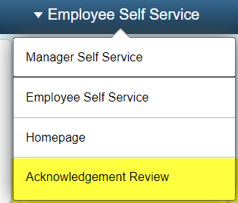
Once you select the page, you will see the following view:
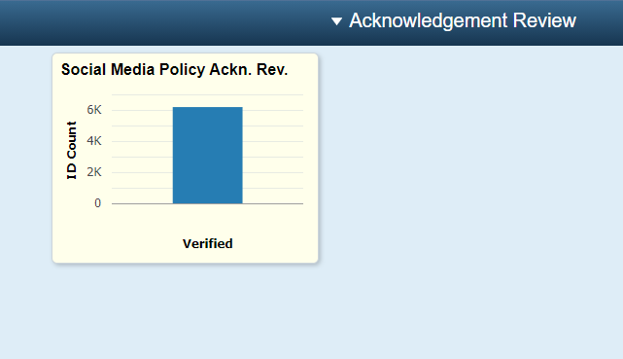
As more policies or standard practices are utilized in EMACS, this page will reflect those changes with additional tiles to assist in the validation and review of data.

Pivot Grid
The Pivot Grid is limited by department security. The user will only be able to see departments that they have security access to view.
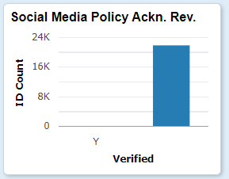
There are several viewing options within the pivot grid. The main view shows the number of people who have and have not completed the acknowledgement.
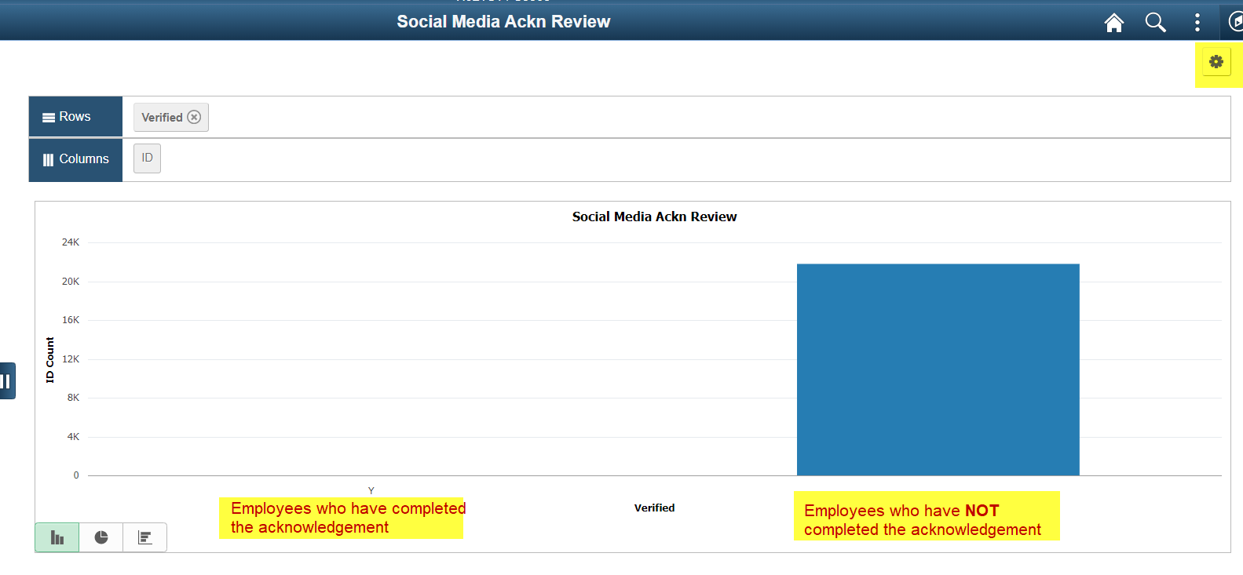
The Excel sheet beneath this chart contains the queried data. The employees who have complete the acknowledgement will appear first.
If you want to see the Excel sheet in its entirety, select the gear wheel icon in the upper right-hand corner, then select Export data.
The other views allow you to see data in relation to department IDs and Union Codes

