Consumer Perception Survey (CPS)
消費者認知問卷調查
For Youth and Families
青少年和家庭
May 15-19, 2023
Tell us what you think about the services you are receiving at this program.
請告訴我們您對您在此計劃中所獲得的服務的看法
Complete a voluntary, anonymous, and confidential survey. Choose how you want to participate:
請完成自願、匿名和保密的問卷調查. 請選擇您想參與的方式：
Secure online survey link for this program:
使用本計劃的安全網路線上調查：
YOUTH青少年
https://uclahs.fyi/2023CPS-Youth
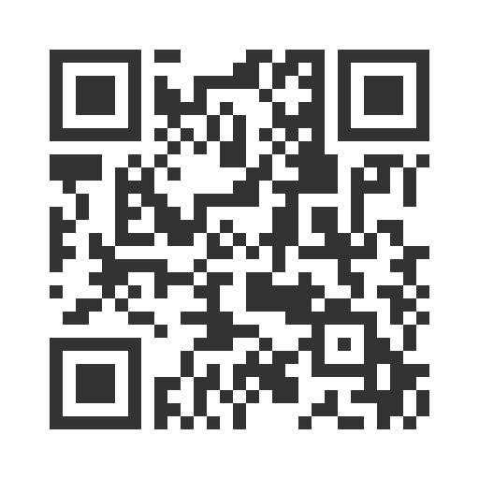
Paper survey form (ask program staff for a form)
使用紙本問卷調查表（請向工作人員索取問卷表格）
Ask program staff if you have questions or would like assistance with the survey!
如果您有任何問題或填寫問卷調查需要幫助，請詢問工作人員
Thank you for participating in this important survey!
感謝您參與這項重要的問卷調查

Consumer Perception Survey (CPS)
消費者認知問卷調查
For Youth and Families
青少年和家庭
May 15-19, 2023
Tell us what you think about the services you are receiving at this program.
請告訴我們您對您在此計劃中所獲得的服務的看法
Complete a voluntary, anonymous, and confidential survey. Choose how you want to participate:
請完成自願、匿名和保密的問卷調查. 請選擇您想參與的方式：
Secure online survey link for this program:
使用本計劃的安全網路線上調查：
FAMILIES OF YOUTH青少年的家人
https://uclahs.fyi/2023CPS-Parent-Family
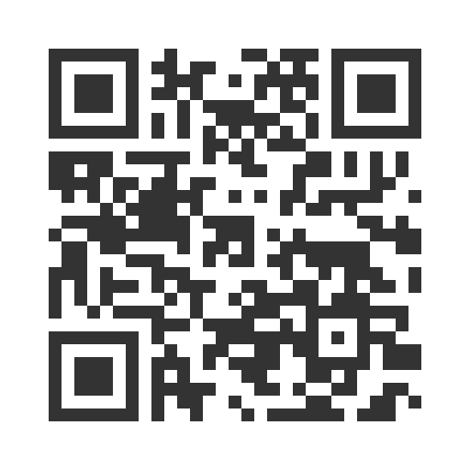
Paper survey form (ask program staff for a form)
使用紙本問卷調查表（請向工作人員索取問卷表格）
Ask program staff if you have questions or would like assistance with the survey! 如果您有任何問題或填寫問卷調查需要幫助，請詢問工作人員
Thank you for participating in this important survey!
感謝您參與這項重要的問卷調查

