Consumer Perception Survey (CPS)
For Youth and Families
May 15-19, 2023
[Counties/providers may tailor this flyer as needed.]
Tell us what you think about the services you are receiving at this program.
Complete a voluntary, anonymous, and confidential survey. Choose how you want to participate:
Secure online survey link for this program:
YOUTH
https://uclahs.fyi/2023CPS-Youth
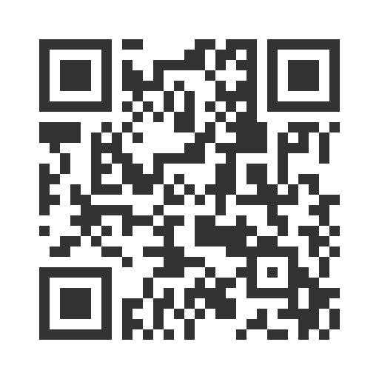
- Paper survey form (ask program staff for a form)
Ask program staff if you have questions or would like assistance with the survey!
Thank you for participating in this important survey!

Consumer Perception Survey (CPS)
For Youth and Families
May 15-19, 2023
[Counties/providers may tailor this flyer as needed.]
Tell us what you think about the services you are receiving at this program.
Complete a voluntary, anonymous, and confidential survey. Choose how you want to participate:
Secure online survey link for this program:

FAMILIES OF YOUTH
https://uclahs.fyi/2023CPS-Parent-Family
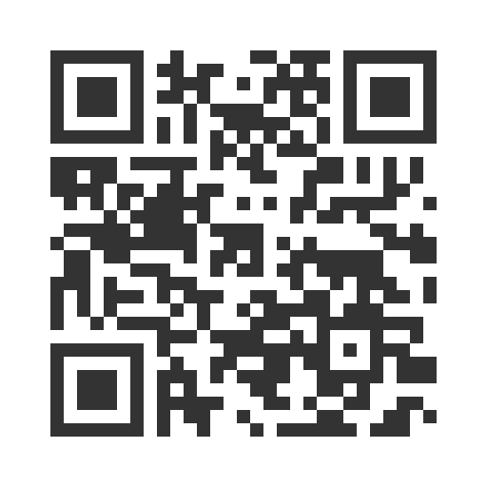

- Paper survey form (ask program staff for a form)
Ask program staff if you have questions or would like assistance with the survey!
Thank you for participating in this important survey!

