Consumer Perception Survey (CPS)
消費者認知問卷調查
For Older Adults 年長者
May 15-19, 2023
Tell us what you think about the services you are receiving at this program.
請告訴我們您對您在此計劃中所獲得的服務的看法
Complete a voluntary, anonymous, and confidential survey. Choose how you want to participate: 請完成自願、匿名和保密的問卷調查. 請選擇您想參與的方式：
Secure online survey link for this program:
使用本計劃的安全網路線上調查：
OLDER ADULT (+QOL) 年長者 及
https://uclahs.fyi/2023CPS-OlderAdult-QOL
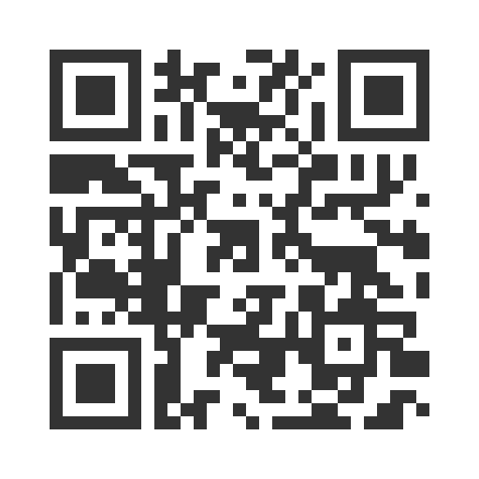
- Paper survey form (ask program staff for a form)
使用紙本問卷調查表（請向工作人員索取問卷表格）
Ask program staff if you have questions or would like assistance with the survey!
如果您有任何問題或填寫問卷調查需要幫助，請詢問工作人員

Thank you for participating in this important survey!
感謝您參與這項重要的問卷調查

