Consumer Perception Survey (CPS)
For Adults
May 15-19, 2023
[Counties/providers may tailor this flyer as needed.]
Tell us what you think about the services you are receiving at this program.
Complete a voluntary, anonymous, and confidential survey. Choose how you want to participate:
Secure online survey link for this program:
ADULT (+QOL)
https://uclahs.az1.qualtrics.com/jfe/form/SV_29w6LdCan1NUu3A
https://uclahs.fyi/2023CPS-Adult-QOL

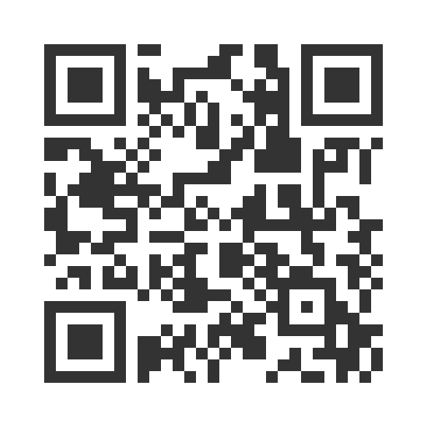
- Paper survey form (ask program staff for a form)
Ask program staff if you have questions or would like assistance with the survey!
Thank you for participating in this important survey!

