Consumer Perception Survey (CPS)
For Adults
May 20-24, 2024
[Counties/providers may tailor this flyer as needed.]
Tell us what you think about the services you are receiving at this program.
Complete a voluntary, anonymous, and confidential survey. Choose how you want to participate:
- Secure online survey link for this program:

ADULT (+QOL)
https://uclahs.fyi/AdultQOL
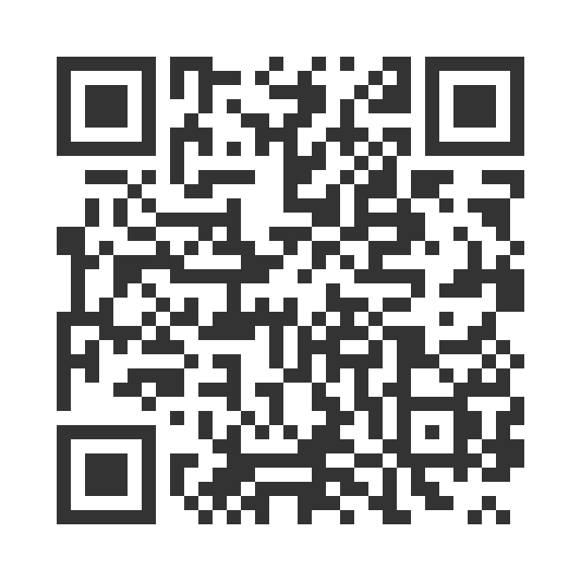

- Paper survey form (ask program staff for a form)
Ask program staff if you have questions or would like assistance with the survey!
Thank you for participating in this important survey!

