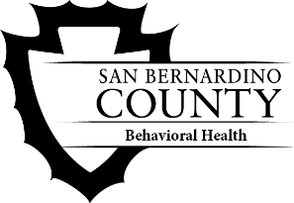
San Bernardino County

Department of Behavioral Health

Social Work Internship Program Application and Instructions

About the Program
To learn more about the program and requirements, please visit our website and view the Social Work Internship Program Brochure:
https://wp.sbcounty.gov/dbh/careers/
Application Submission
To apply to the Social Work Intern Program, email the items listed below to internprograms@dbh.sbcounty.gov.
  - Completed Application Form
  - Resume
You will receive a confirmation email letting you know your application was received.
Important Dates
Deadline:
Applications for the Fall Intern Cohort are due on March 8, 2024.
Interviews:
Interviews will be conducted mid-March through early April 2024.
Selection:
Positions will be offered mid-April 2024.
Start Date:
Students will begin their internship mid-Aug. 2024.

Social Work Internship Program Application
Contact Information
Name: |  | Date:
Address:
Home Phone: | Cell Phone:
Personal Email:
School Email:

University Information
Name of University:
Field Director:
Address:
Office Phone: | Cell Phone:
Program: BSW MSW 1st Year MSW 2nd Year
Requested Internship Start Date (Month/Year):

Additional Information
Bilingual: Yes No | Language:
Verbal: Yes No | Written: Yes No

Page 1 of 4
Question 1/3: Why are you interested in an internship position with San Bernardino County Department of Behavioral Health?
Page 2 of 4
Question 2/3: Based upon your knowledge of the Department of Behavioral Health, how do you see an intern experience here fitting with your career goals?
Page 3 of 4
Question 3/3: What personal qualities do you feel you will bring to this internship?
Page 4 of 4

