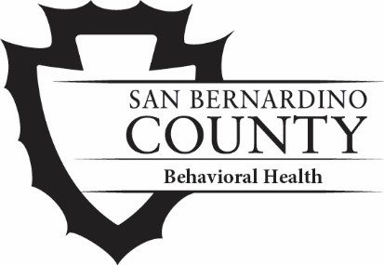

San Bernardino County
Department of Behavioral Health
Marriage & Family Therapy Internship Program
Application and Instructions
About the Program
To learn more about the program and requirements, please visit our website and view the Marriage and Famly Therapy Internship Program Brochure:
https://wp.sbcounty.gov/dbh/careers/
Application Submission
To apply to the Marriage and Family Therapy Internship Program, email the items listed below to internprograms@dbh.sbcounty.gov.
Completed Application Form
Resume/Vitae
You will receive a confirmation email letting you know your application was received.
Important Dates
Deadline:
Applications are due on Feb. 23, 2024.
Interviews:
Interviews will be conducted in late February through mid-March 2024.
Selection:
Positions will be offered in early April 2024.
Start Date:
Students will begin internship orientation in early July 2024 and be placed in their clinical sites approximately mid-July 2024.

Marriage & Family Therapy Internship Program Application

Contact Information
Name: | Date:
Address:
Home Phone: | Cell Phone:
Personal Email:
School Email:

University Information
Name of University:
Practicum Director:
Address:
Phone: | Cell Phone:
At least 12 semester or 18 quarter units will be completed by the beginning of the Internship.
☐ Yes ☐ No
Expected Date of Graduation:
Requested Internship Start Date (Month/Year):

Additional Information
Bilingual: ☐ Yes ☐ No | Language:
Verbal: ☐ Yes ☐ No | Written: ☐ Yes ☐ No

Question 1/3: Why are you interested in an internship position with the San Bernardino County Department of Behavioral Health?
Question 2/3: Based upon your knowledge of the Department of Behavioral Health, how do you see an intern experience here fitting with your career goals?
Question 3/3: Please provide a brief personal statement that tells us who you are. It is entirely up to you to decide what information to present.

