(Facility’s Name)
(Facility’s Address)
(Facility’s Phone Number)
BODY ART CONSENT RELEASE FORM FOR CLIENTS UNDER 18 YEARS OF AGE
Client’s Name |  | Date

Address

City |  | State |  | Zip

DOB |  | Age |  | Phone Number

Parent/Legal Guardian Name |  | Type of ID

Physician’s Name |  | Physician’s Signature

Permanent Cosmetic Technician Registration No.

Restrictions on the Performance of Body Art
119302. (a) Pursuant to Section 653 of the Penal Code, a client shall be at least 18 years of age to be offered or to receive a tattoo or permanent cosmetics application, regardless of parental consent. (b) Pursuant to Section 652 of the Penal Code, persons under 18 years of age shall not be offered or receive a body piercing unless the piercing is performed in the presence of his or her parent or guardian. (c) A client shall be at least 18 years of age to be offered or to receive a branding, regardless of parental consent. (d) The piercing or application of permanent cosmetics to the nipples or genitals of a minor is prohibited. The application of permanent cosmetics to the nipples of a minor is authorized when applied by a registered permanent cosmetic technician with the consent of the minor’s parent or guardian and as directed by a physician. (e) A body art facility may refuse to perform body piercing on a minor, regardless of parental or guardian consent.

Prior to the performance of body art, the client’s parent or legal guardian shall read, complete, and sign the consent form that includes all of the following:
Location of Body Art | Body Art Jewelry Description
Left Ear Transverse Lobe Piercing  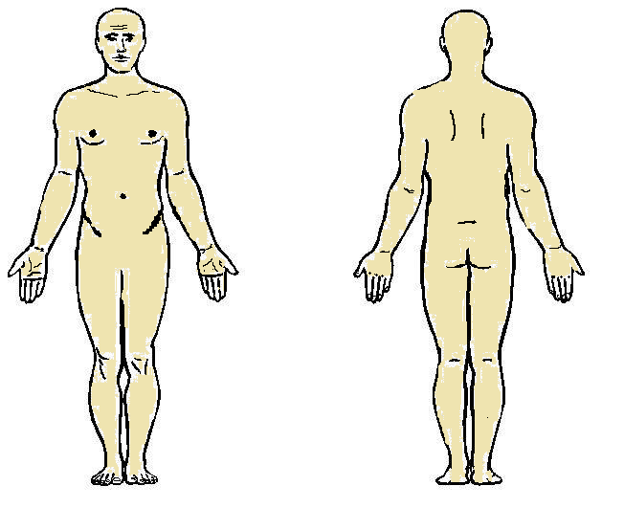 | 10 Gauge ASTM F 136 6A4V Titanium Curved Barbell  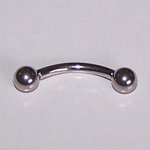

Initials | I acknowledge that my (Son/Daughter) may experience certain amount of pain, minor bleeding, bruising, redness or other discoloration, and swelling at the procedure site area during and after the (body art) procedure.
Initials | I acknowledge that an infection is always possible as a result of obtaining a (body art), particularly in the event that I do not take proper care of my (Son/Daughter) (body art).
Initials | I acknowledge receipt of written instructions advising me of proper care of my (Son/Daughter) (body art) and recognize the absolute necessity of following those written instructions.
Initials | I acknowledge that (body art) is a permanent change to my (Son/Daughter) appearance and removal may not result in the restoration of the skin to its exact original condition.
Initials | I acknowledge that tattoo inks, dyes, and pigments have not been approved by the federal Food and Drug Administration and the health consequences of using these products are unknown.
Initials | POST-PROCEDURE (AFTER CARE) INSTRUCTIONS  INFORMATION ON THE CARE OF THE PROCEDURE SITE.  RESTRICTIONS ON PHYSICAL ACTIVITIES DURING BODY ART HEALING  - Bathing  - Recreational water activities  - Gardening  - Contact with animals  SIGNS OF NORMAL HEALING PROCESS  - A Little Bit of Redness  - Itching  - Peeling  - Scabbing  - Light Swelling  SIGNS AND SYMPTOMS OF INFECTION INDICATING THE NEED TO SEEK MEDICAL CARE:  Redness, swelling, tenderness of the procedure site, red streaks going from the procedure site towards the heart, elevated body temperature, or purulent drainage from the procedure site.  Facility’s Additional Information If Applicable

I have read this body art consent release form and agree to its terms.

Parent/Legal Guardian Signature |  | Date

Do Not Write Below This Line (for Body Art Practitioner Use Only)
Client’s Name |  | Date

Body Art Practitioner’s Name

Disposable, Single-use, Pre-Sterilized Equipment

Needle  Item# Lot# Exp. Date | Tube  Item# Lot# Exp. Date

