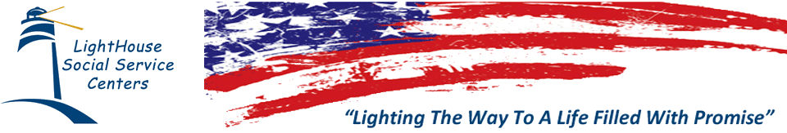

## LightHouse Social Service Centers

## LightHouse Social Service Centers, a 501©(3) public-benefit corporation, is dedicated to enhancing lives and meeting the diverse needs of individuals, families, and communities. Through the utilization of comprehensive integrated social service systems, Lighthouse Social Service Centers supports clients in breaking the cycles of addiction and homelessness, works to keep families together, and strives to build strong healthy communities.

## Supportive Service for Veteran Families Program (SSVF)

Lighthouse Social Service Centers’ SSVF program is a short-term, crisis intervention, case management program that provides rapid re-housing services to veterans and their families. LightHouse will be providing program information and answering questions regarding our supportive service program includes: housing search and housing acquisition assistance, limited temporary financial assistance and case management services.

## Please contact LightHouse for assistance: Outreach: 951-255-8563 or 951-269-5634

Case Managers:

Liz Padilla

Tania Johnson

Mark Houck

Robert Caruthers

Gwendolyn Criswell

Housing Specialist: DeVondre Adams

Outreach Specialists:

David Rabindranath

Darrel Sampson

LightHouse Social Service Centers

1003 E. Cooley Drive

Suite # 205

Colton, CA 92324

Office # 951-571-3533

E-mail Address: Davidr@lighthouse-ssc.org